Square Gyrobicupola

Definition
# Source: AI Source: Provided by: [Data Path: Persons Table -> ID Column: 1, Name_En Column: Motasem Essam] -> From: [ChatGPT] on [7/25/2026]
A Square Gyrobicupola is a convex polyhedron formed by joining two identical square cupolas along their regular octagonal bases, with one cupola rotated by ${45}^{∘}$ relative to the other.
It is the 29th Johnson solid (J29). It consists of eight equilateral triangular faces and ten square faces.
The rotation causes the triangular faces of one cupola to meet the square faces of the other, distinguishing it from the Square Orthobicupola.

Geometric Structure
# Source: AI Source: Provided by: [Data Path: Persons Table -> ID Column: 1, Name_En Column: Motasem Essam] -> From: [ChatGPT] on [7/25/2026]
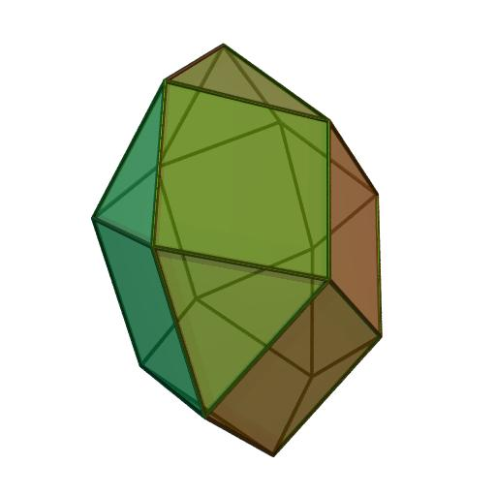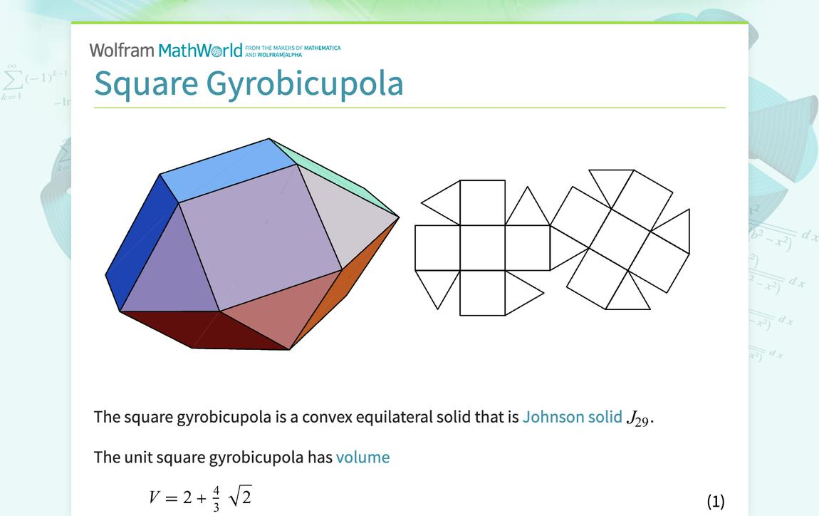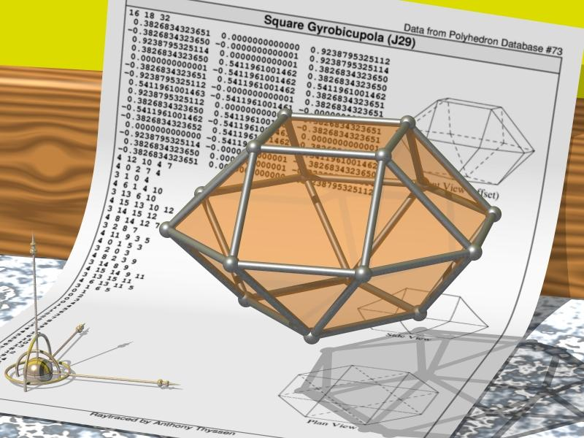
The solid consists of:
- Two opposite square faces forming the upper and lower ends.
- Eight additional square faces around the lateral structure.
- Eight equilateral triangular faces.
- Sixteen vertices and thirty-two edges.
The two octagonal joining bases are internal and are not counted as external faces.

Face Composition
# Source: AI Source: Provided by: [Data Path: Persons Table -> ID Column: 1, Name_En Column: Motasem Essam] -> From: [ChatGPT] on [7/25/2026]
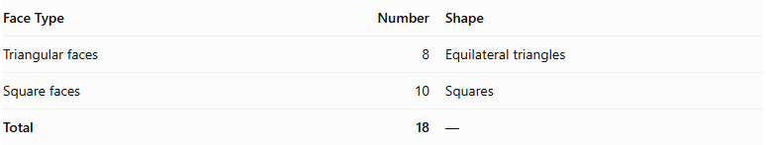
Face Type | Number | Shape
Triangular faces | 8 | Equilateral triangles
Square faces | 10 | Squares
Total | 18 | —

Mathematical Properties
# Source: AI Source: Provided by: [Data Path: Persons Table -> ID Column: 1, Name_En Column: Motasem Essam] -> From: [ChatGPT] on [7/25/2026]
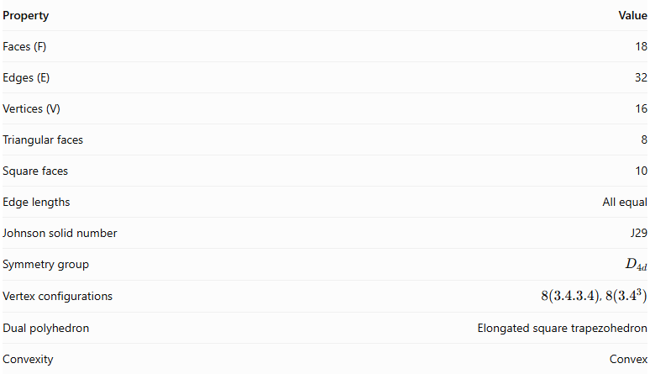
Property | Value
Faces (F) | 18
Edges (E) | 32
Vertices (V) | 16
Triangular faces | 8
Square faces | 10
Edge lengths | All equal
Johnson solid number | J29
Symmetry group | $$D_{4d}$$
Vertex configurations | $8(3.4.3.4)$, $8({3.4}^{3})$
Dual polyhedron | Elongated square trapezohedron
Convexity | Convex
Euler's formula:
$$V-E+F=16-32+18=2$$

Surface Area
# Source: AI Source: Provided by: [Data Path: Persons Table -> ID Column: 1, Name_En Column: Motasem Essam] -> From: [ChatGPT] on [7/25/2026]
For edge length $a$:
$$S=8(\frac{\sqrt{3}}{4}a^{2})+10a^{2}$$
$$\boxed{S=(10+2\sqrt{3})a^{2}}$$

Volume
# Source: AI Source: Provided by: [Data Path: Persons Table -> ID Column: 1, Name_En Column: Motasem Essam] -> From: [ChatGPT] on [7/25/2026]
$$\boxed{V=\frac{6+4\sqrt{2}}{3}a^{3}}$$
For unit edge length:
$$V≈3.8856$$

Geometric Characteristics
# Source: AI Source: Provided by: [Data Path: Persons Table -> ID Column: 1, Name_En Column: Motasem Essam] -> From: [ChatGPT] on [7/25/2026]
- Convexity: It is a convex polyhedron.
- Uniformity: It has regular polygon faces and equal edge lengths, but it is not a uniform polyhedron.
- Vertex configuration: It has two types of vertex arrangements:
- Eight vertices with configuration $3.4.3.4$.
- Eight vertices with configuration $3.4.4.4$, also written ${3.4}^{3}$.
- Symmetry: It has $D_{4d}$ symmetry, associated with fourfold rotational and improper rotational symmetries.
- Duality: Its dual is the elongated square trapezohedron.

Construction of Square Gyrobicupola

Geometric Instruments Used
# Source: AI Source: Provided by: [Data Path: Persons Table -> ID Column: 1, Name_En Column: Motasem Essam] -> From: [ChatGPT] on [7/25/2026]
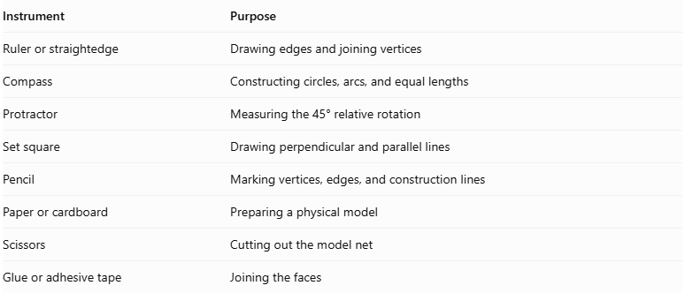
Instrument | Purpose
Ruler or straightedge | Drawing edges and joining vertices
Compass | Constructing circles, arcs, and equal lengths
Protractor | Measuring the 45° relative rotation
Set square | Drawing perpendicular and parallel lines
Pencil | Marking vertices, edges, and construction lines
Paper or cardboard | Preparing a physical model
Scissors | Cutting out the model net
Glue or adhesive tape | Joining the faces

Instrument-Based Construction Procedures

Construct the First Square Cupola
# Source: AI Source: Provided by: [Data Path: Persons Table -> ID Column: 1, Name_En Column: Motasem Essam] -> From: [ChatGPT] on [7/25/2026]
- Draw a regular octagon using a compass, ruler, and protractor.
- Construct a square above the octagonal base, following the standard square-cupola arrangement.
- Around the octagon, construct eight alternating lateral faces:
- Four equilateral triangular faces.
- Four square faces.
- Ensure that the triangular and square faces have matching edge lengths.
- Check that the square top is correctly connected to the lateral faces.

Construct the Second Square Cupola
# Source: AI Source: Provided by: [Data Path: Persons Table -> ID Column: 1, Name_En Column: Motasem Essam] -> From: [ChatGPT] on [7/25/2026]
- Draw another regular octagon congruent to the first.
- Construct a congruent square top.
- Construct four equilateral triangular and four square lateral faces.
- Ensure that all corresponding dimensions match the first cupola.
- Keep the second cupola separate until the rotational arrangement is established.

Rotate the Second Cupola
# Source: AI Source: Provided by: [Data Path: Persons Table -> ID Column: 1, Name_En Column: Motasem Essam] -> From: [ChatGPT] on [7/25/2026]
- Identify the center of the shared octagonal base.
- Mark the required rotation angle:
$$α={45}^{°}$$
- Rotate the second cupola by ${45}^{°}$ around the central axis of its octagonal base.
- Check that the two octagonal bases remain congruent and can be matched edge-to-edge.

Join the Two Cupolas
# Source: AI Source: Provided by: [Data Path: Persons Table -> ID Column: 1, Name_En Column: Motasem Essam] -> From: [ChatGPT] on [7/25/2026]
- Place the two octagonal bases opposite one another.
- Match the vertices and edges of the shared octagons.
- Join the cupolas in the gyro arrangement.
- Ensure that the lateral faces meet edge-to-edge around the joining region.
- Treat the shared octagonal bases as internal faces.
- Check that the exterior consists of eight equilateral triangles and ten squares.

Complete the Solid Drawing
# Source: AI Source: Provided by: [Data Path: Persons Table -> ID Column: 1, Name_En Column: Motasem Essam] -> From: [ChatGPT] on [7/25/2026]
- Draw the two exposed square bases at opposite ends.
- Complete the eight triangular and ten square exterior faces.
- Use solid lines for visible edges.
- Use dashed lines for hidden edges when necessary.
- Verify that the final solid has 18 faces, 32 edges, and 16 vertices.
Construction restriction: This procedure uses geometric instruments, angle measurements, and geometric relationships. It does not use coordinate-based construction.

Related Geometric Solids
# Source: AI Source: Provided by: [Data Path: Persons Table -> ID Column: 1, Name_En Column: Motasem Essam] -> From: [ChatGPT] on [7/25/2026]
- Square Cupola: The component solid used to construct the Square Gyrobicupola.
- Square Orthobicupola (J28): Formed by joining two square cupolas without relative rotation.
- Pentagonal Gyrobicupola (J31): A corresponding gyrobicupola constructed from two pentagonal cupolas.
- Elongated Square Gyrobicupola (J37): A related solid formed by inserting an octagonal prism between the two square cupolas.
- Elongated Square Trapezohedron: The dual polyhedron of the Square Gyrobicupola.

Main Classification
# Source: AI Source: Provided by: [Data Path: Persons Table -> ID Column: 1, Name_En Column: Motasem Essam] -> From: [ChatGPT] on [7/25/2026]
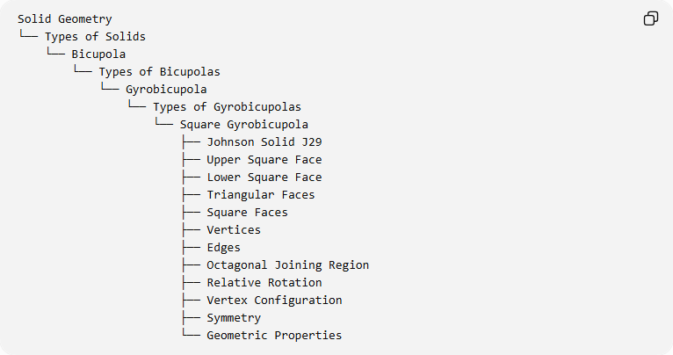
Solid Geometry
└── Types of Solids
└── Bicupola
└── Types of Bicupolas
└── Gyrobicupola
└── Types of Gyrobicupolas
└── Square Gyrobicupola
├── Johnson Solid J29
├── Upper Square Face
├── Lower Square Face
├── Triangular Faces
├── Square Faces
├── Vertices
├── Edges
├── Octagonal Joining Region
├── Relative Rotation
├── Vertex Configuration
├── Symmetry
└── Geometric Properties

Important Distinction
# Source: AI Source: Provided by: [Data Path: Persons Table -> ID Column: 1, Name_En Column: Motasem Essam] -> From: [ChatGPT] on [7/25/2026]
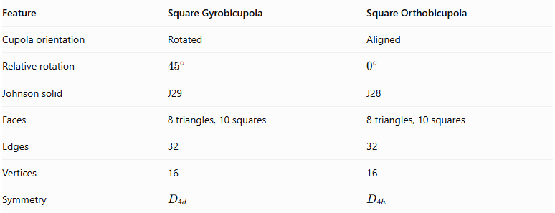
Feature | Square Gyrobicupola | Square Orthobicupola
Cupola orientation | Rotated | Aligned
Relative rotation | $${45}^{∘}$$ | $$0^{∘}$$
Johnson solid | J29 | J28
Faces | 8 triangles, 10 squares | 8 triangles, 10 squares
Edges | 32 | 32
Vertices | 16 | 16
Symmetry | $$D_{4d}$$ | $$D_{4h}$$
Both solids have the same face composition and mathematical counts, but their cupolas have different relative orientations.

Key Points
# Source: AI Source: Provided by: [Data Path: Persons Table -> ID Column: 1, Name_En Column: Motasem Essam] -> From: [ChatGPT] on [7/25/2026]
- The Square Gyrobicupola is Johnson solid J29.
- It is constructed from two square cupolas joined at their octagonal bases.
- One cupola is rotated ${45}^{∘}$ relative to the other.
- It has 8 equilateral triangular faces and 10 square faces.
- It has 18 faces, 32 edges, and 16 vertices.
- Its dual is the elongated square trapezohedron.

Conclusion
# Source: AI Source: Provided by: [Data Path: Persons Table -> ID Column: 1, Name_En Column: Motasem Essam] -> From: [ChatGPT] on [7/25/2026]
The Square Gyrobicupola is a convex Johnson solid formed by joining two square cupolas with a ${45}^{∘}$ relative rotation. Its combination of triangular and square faces creates a distinctive bicupola structure with 18 faces, 32 edges, and 16 vertices.

